LAB Logbook

Lab 1
Thursday, 21st September 2023
Some Pandas classes from the previous class:
- head(n): this is used to return the first n set of rows in a dataset. When there is no n, head() returns the first 5 rows in a dataset.
- read_csv(): This class/function is used to ‘read’ the entire dataset or make the entire dataset available to be manipulated on Jupyter notebook. The file is usually in .csv format.
- Shape(): this function is used to find the exact number of columns and rows in a dataset.
- Info(): this class is used to outline the columns in the dataset and their attributes e.g., the datatype.
- astype(): This function is used to change or update the datatype of a particular column.
Lab 2
28th September 2023
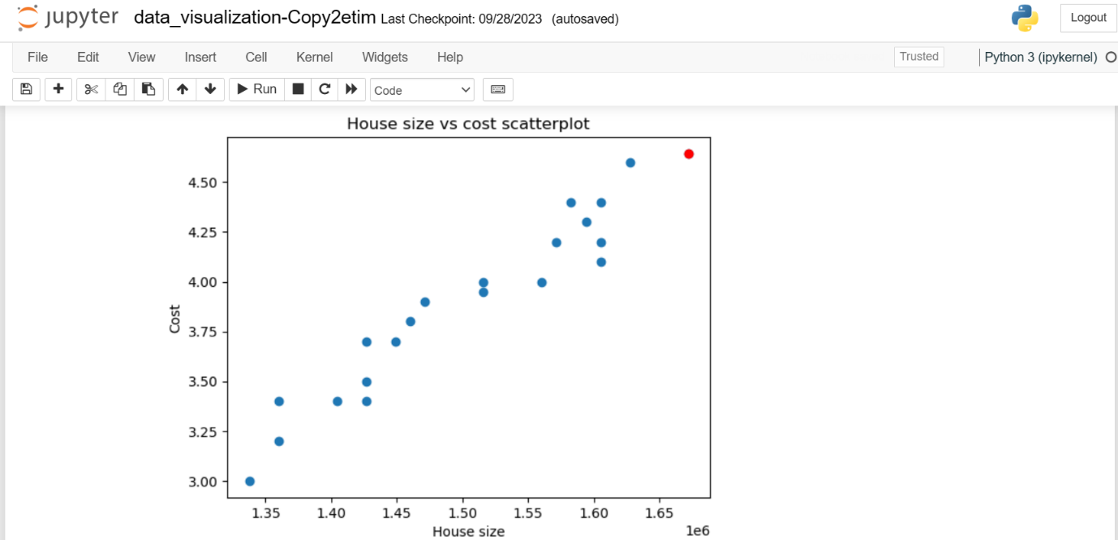
image of the generated scatter plot between house size and cost.
new_house = seed * 0.75 where seed is 2229453
new_house =1672089.75
last_cost 4.64420072 where last_cost is the guessed cost of a house of the size 1672089.75

Lab 3
- A plotted graph illustrating the relationship between iterations and cost, using the values stored in the list J_history.

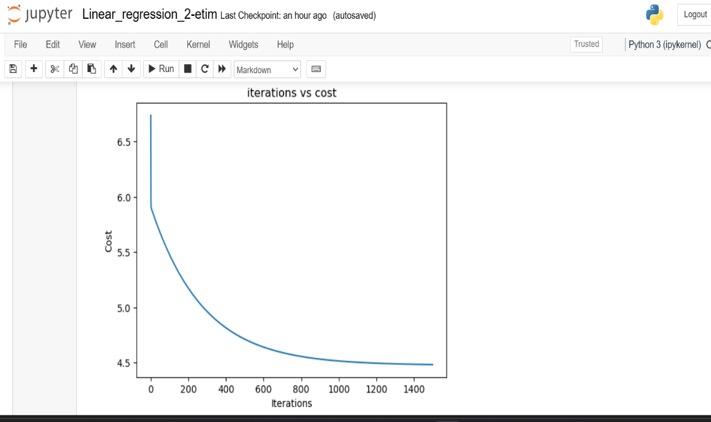

Predictions for the two unknown values based on input population data, where the population of the first city is set to 10 times less than your Student ID (SID), and the population of the second city is set to 30 times less than your SID.

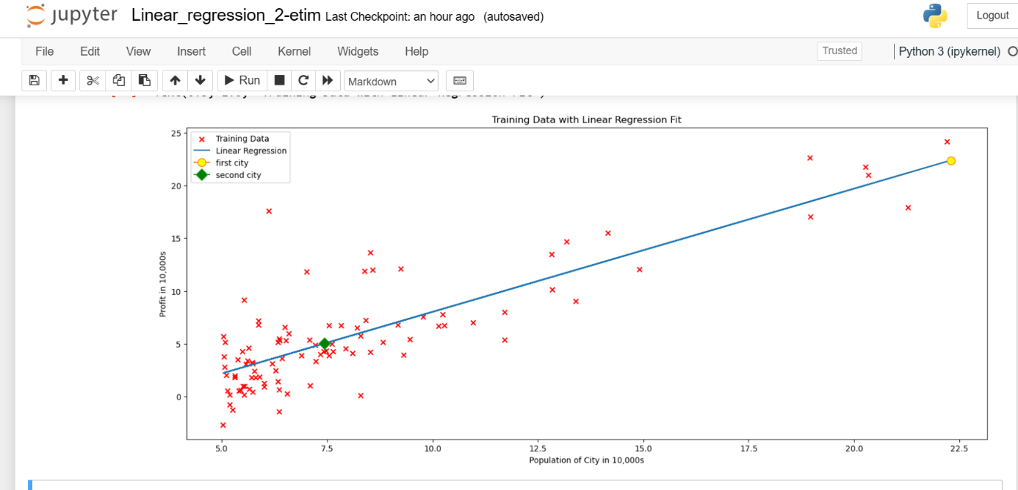

Lab 4

1. Plot the loss function.
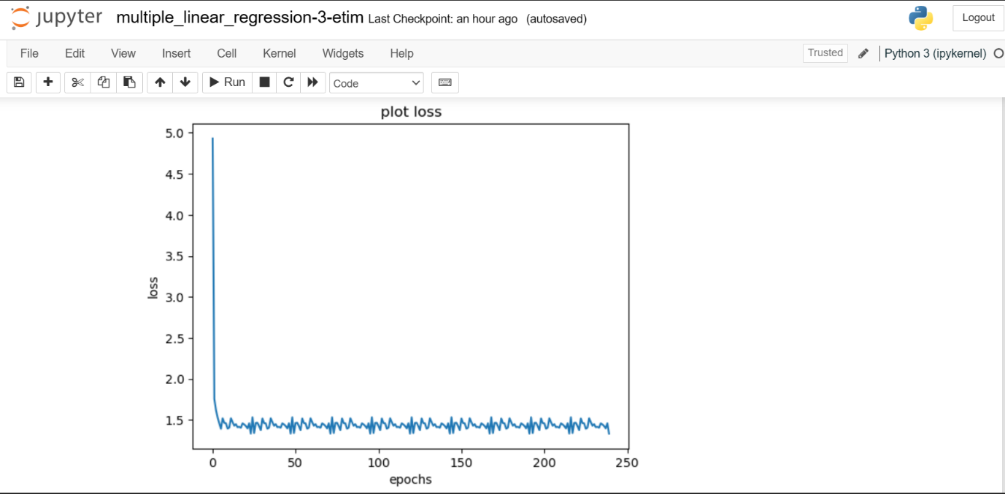

2. Record the output of all the predictions on the test data; i.e., all the predicted y values.
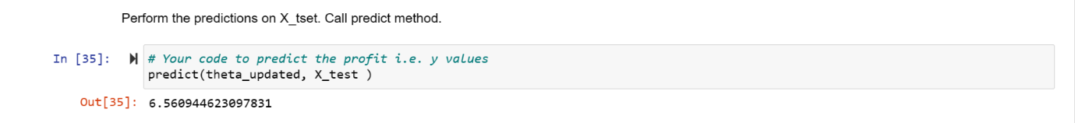

Lab 5
Final accuracy

Lab 6
Final result for task 1:
O1 = 0.8098431536289358 ≈ 1
O2 = 0.7209122856471304 ≈ 1
Task 2
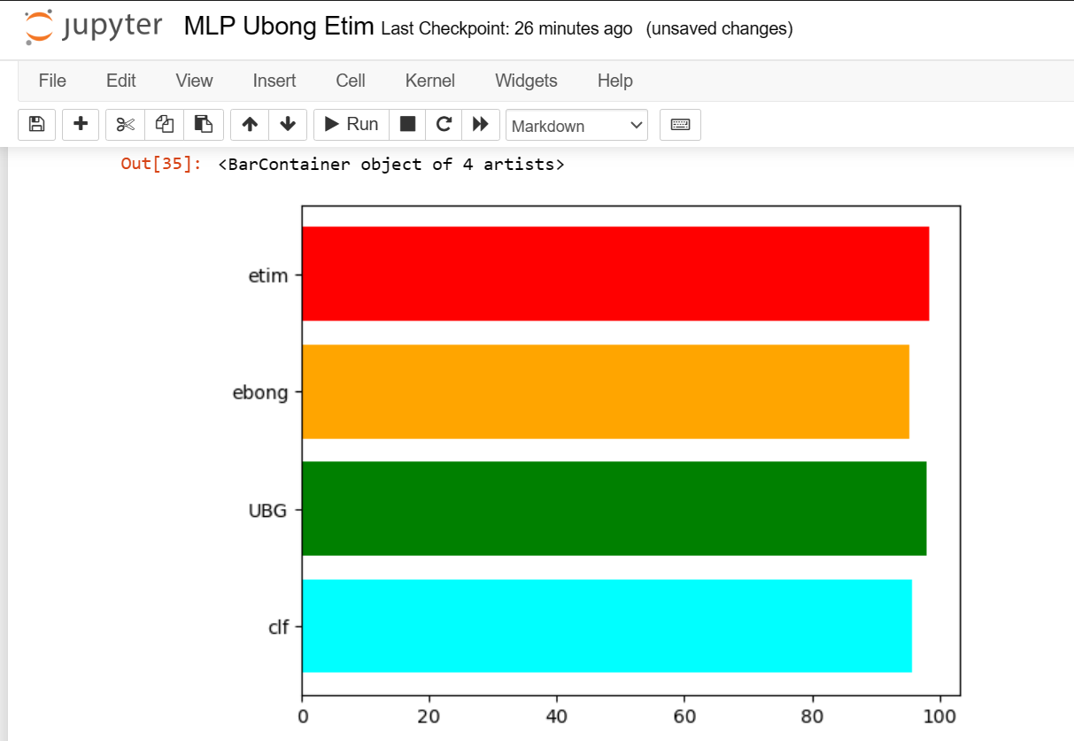

Lab 7
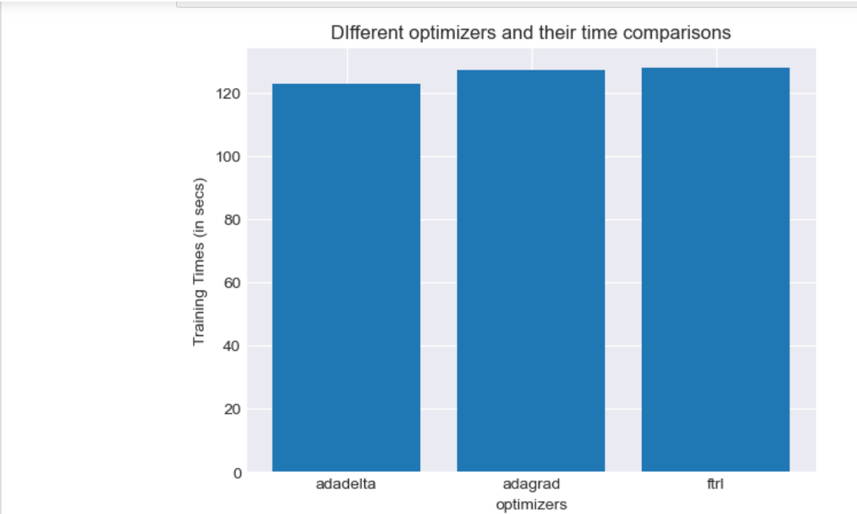
Figure showing graphs of time taken by each optimizer.
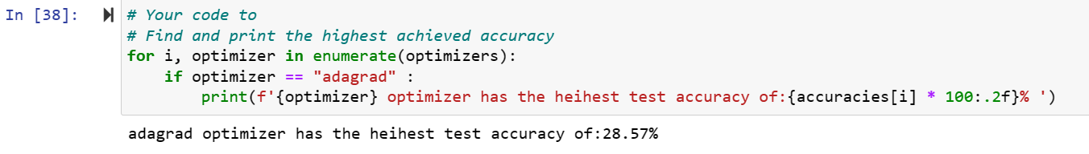
Figure showing the highest optimizer accuracy.
Lab 8
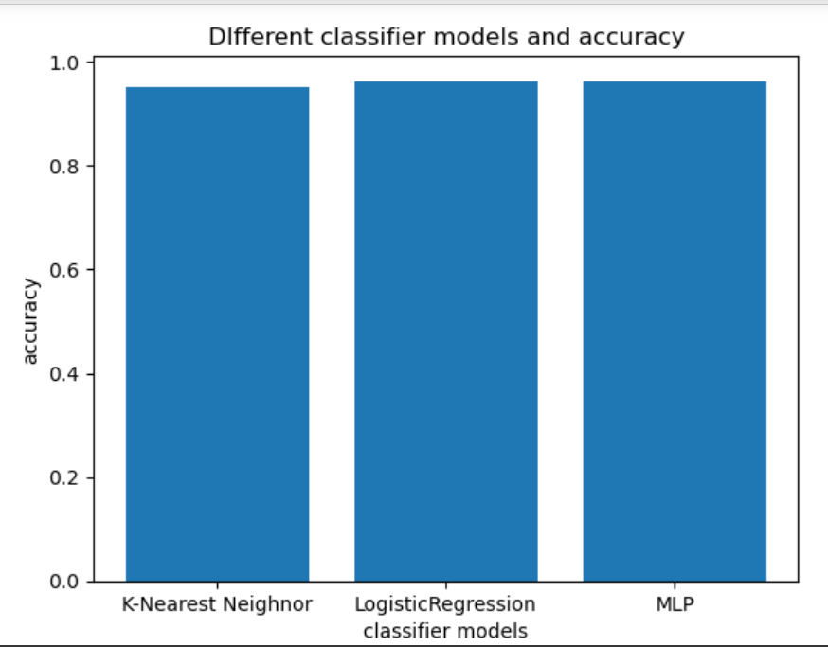
All three models performed rather similarly to one another in accuracy.

Lab 9
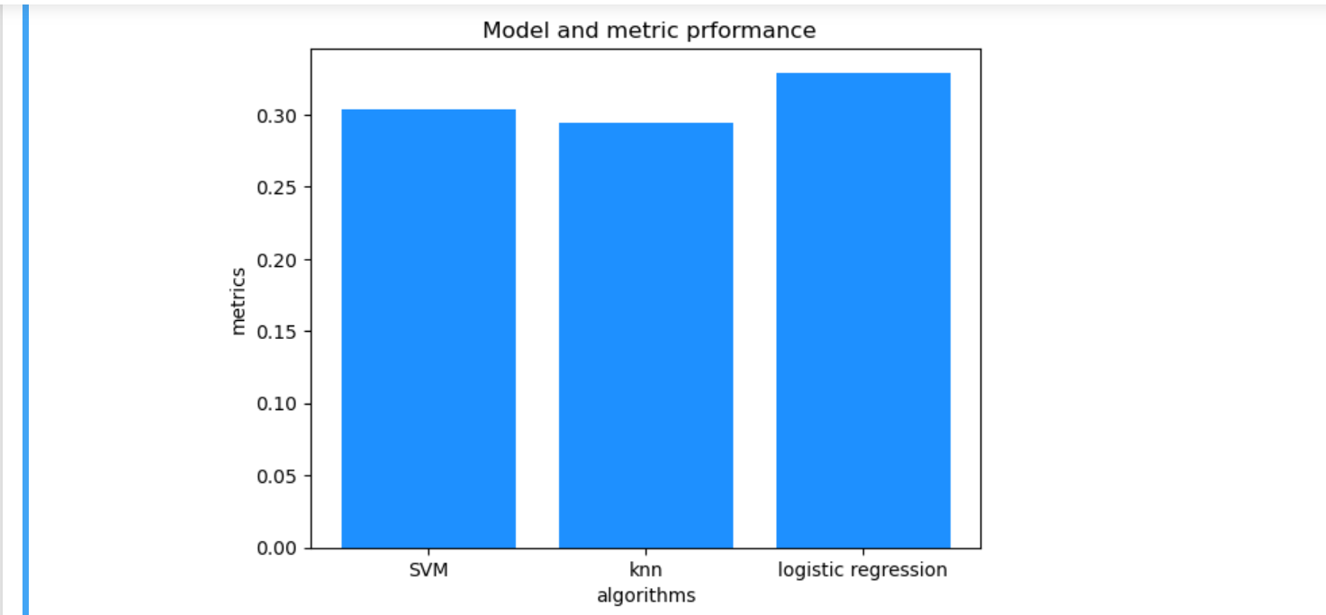
Logistic regression had the best performance of all the three models and based on the confusion matrix, the best performing category is category 2 which is the prediction for students who did poorly. The lest performing categories were 0 and 1 which are the predictions for students doing good and excellent.

Lab 10
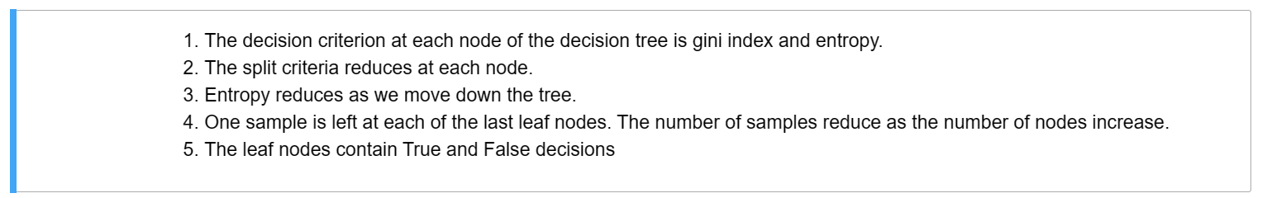
Lab 11
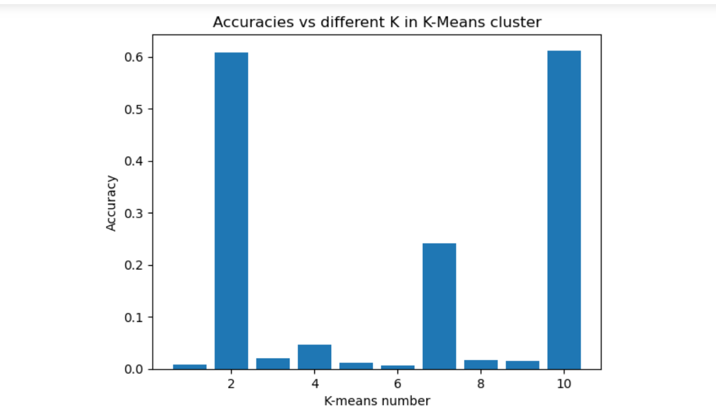
Lab 12

